Department Steering Group (Project focus aspects only)

|  |  |
| --- | --- |
| **Purpose** | Check in-year projects against each other when they are delivering similar services or delivering into the same layer of the architecture. Issues and interfaces and opportunities can be raised and sent to the Sub-portfolios /PMs to resolve. Each meeting will focus on a different set of services and a different layer, so that over the course of the year the full stack and the whole range of Customer services can be covered. The meeting also provides a forum to identify any IT synergies , opportunities or needs and as a result to propose new projects covering key IT gaps or capitalising on key IT areas where IT can show anticipate and shape future business need.   1. Agree one cluster of similar services, and one layer of the Stack to investigate per meeting 2. Review a cluster of similar services being added/ enhanced 3. Review Projects at one layer in the Stack 4. Review a selection of Plans and performance of projects in flight 5. Communicate specific areas agreed for Sub-portfolio and PM attention |

|  |  |  |  |
| --- | --- | --- | --- |
| **Attendees** | Functional leads  PMO  Requested: Enterprise architect.  Sub-portfolio lead: optional | **Authority** | 1. Raise Change requests to be considered by PMs / Sub-portfolios,, where scope or interfaces overlap between projects 2. Recommend projects, for consideration at the ARB, which will improve the overall IT service offering, or the resilience of the Stack 3. Raise risks and issues which must be considered by PMs or Sub-portfolios 4. Recommend |
| **Inputs** | * Agreed infrastructure layer to consider for this meeting * Agreed service cluster to consider for this meeting * Portfolio and pipeline lists   + Grouped by Business function   + Grouped by Stack level | **Output** | 1. A list of scope or interface issues to be sent to the respective Sub-portfolio 2. A list of new Services or Projects for consideration, for next year’s portfolio 3. Recommendations to the PMO for any Rolling Portfolio Process to defer a project, or bring a project into active. |

|  |  |  |  |  |  |
| --- | --- | --- | --- | --- | --- |
| **Frequency** | Once a month | **Chair** | TBA | **Escalation** | TBA |

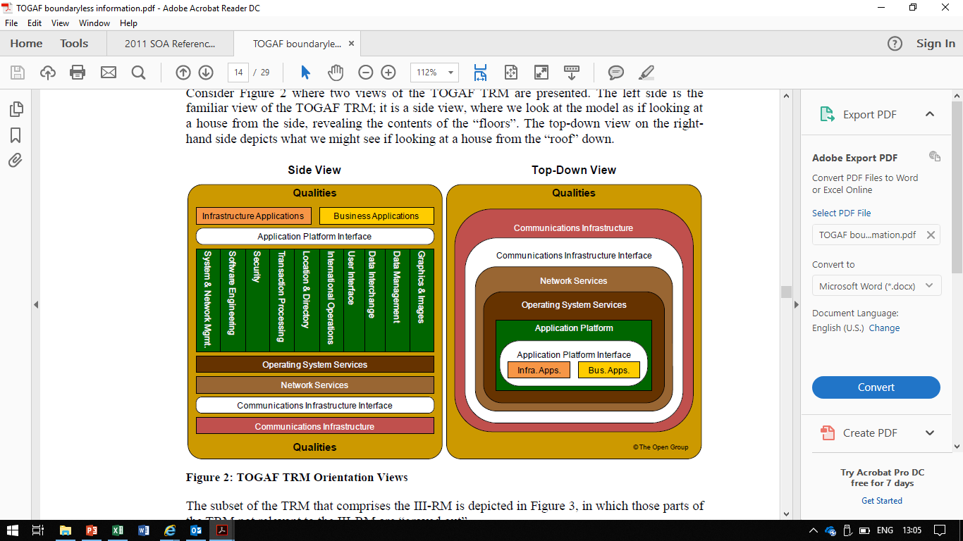

Review projects delivering in a given layer

dd/mm/yyyy

2

|  |
| --- |
| * Agree on 1 layer to review per meeting * Current projects   + Compare projects affecting that layer   + Look for issues / efficiencies / interfaces not yet considered   + Accordingly suggest any scope changes (follow up after meeting) * Future projects   + Where is the layer in its service lifecycle ? (early, maintain, life extend, replace etc)   + Are there any projects we should consider for the health of this layer ? |

Name | Org Unit Presentation Title

dd/mm/yyyy

2

|  |
| --- |
| Review a cluster of similar services being added/ enhanced   * Agree on 1 cluster of related services to review that meeting * Current projects   + Compare projects delivering aspects of these services   + Look for issues / efficiencies / interfaces not yet considered * Future projects   + Is this a cluster of services that will be more or less important in future ?   + Are there any technology “Silver bullet” for lots of services in this space ? |

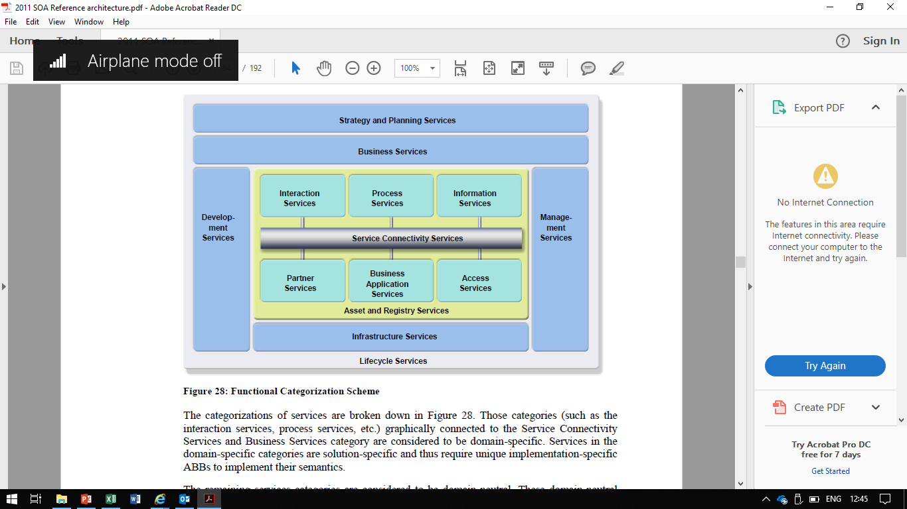

Source: Extract from Open Group’s SOA 2011

Example cluster of related Services

Create & Amend Purchase Requisitions   
Access requisitions and confirm policy compliance

Process/Review & approve Requisitions

Example: one way of clustering services conveniently

* Find a better balance point between an IT – perspective and business needs

Benefits of doing this.

|  |
| --- |
|  |
|  |

Organisation IT Inspires and informs

Building a Organisation IT Vision

* Start to anticipate future business demand, and try to “build-out” ahead of this demand in a IT-centric way. i.e. in a way which is technically efficient.
* Inspire the business functions with what new services can be achieved , so that they select from the IT list

\

